**DAILY ONLINE ACTIVITIES SUMMARY**

|  |  |  |  |  |  |  |  |
| --- | --- | --- | --- | --- | --- | --- | --- |
| **Date:** | **22nd MAY 2020** | | | | **Name:** | **K.ISHA HEGDE.** | |
| **Sem & Sec** | **4sem A** | | | | **USN:** | **4al18cs031** | |
| **Online Test Summary** | | | | | | | |
| **Subject** | | **Operating system** | | | | | |
| **Max. Marks** | | **30** | | **Score** | | **21** | |
| **Certification Course Summary** | | | | | | | |
| **Course** | **Digital security awareness** | | | | | | |
| **Certificate Provider** | | | **ALISON** | **Duration** | | | **2hrs** |
| **Coding Challenges** | | | | | | | |
| **Problem Statement:2 programs** | | | | | | | |
| **Status:executed** | | | | | | | |
| **Uploaded the report in Github** | | | | **Yes** | | | |
| **If yes Repository name** | | | | **[https://github.com/iishaii/locked-down_coding](https://github.com/iishaii/locked-down_coding" \o "https://github.com/iishaii/locked-down_coding)** | | | |
| **Uploaded the report in slack** | | | | **Yes** | | | |

Online Test Details: (Attach the snapshot and briefly write the report for the same)

Certification Course Details: (Attach the snapshot and briefly write the report for the same)

Coding Challenges Details: (Attach the snapshot and briefly write the report for the same)

**Online Test Summary:**

Today **OPERATING SYSTEMS (18cs43)** was conducted of first module. Total marks for the test was 30.

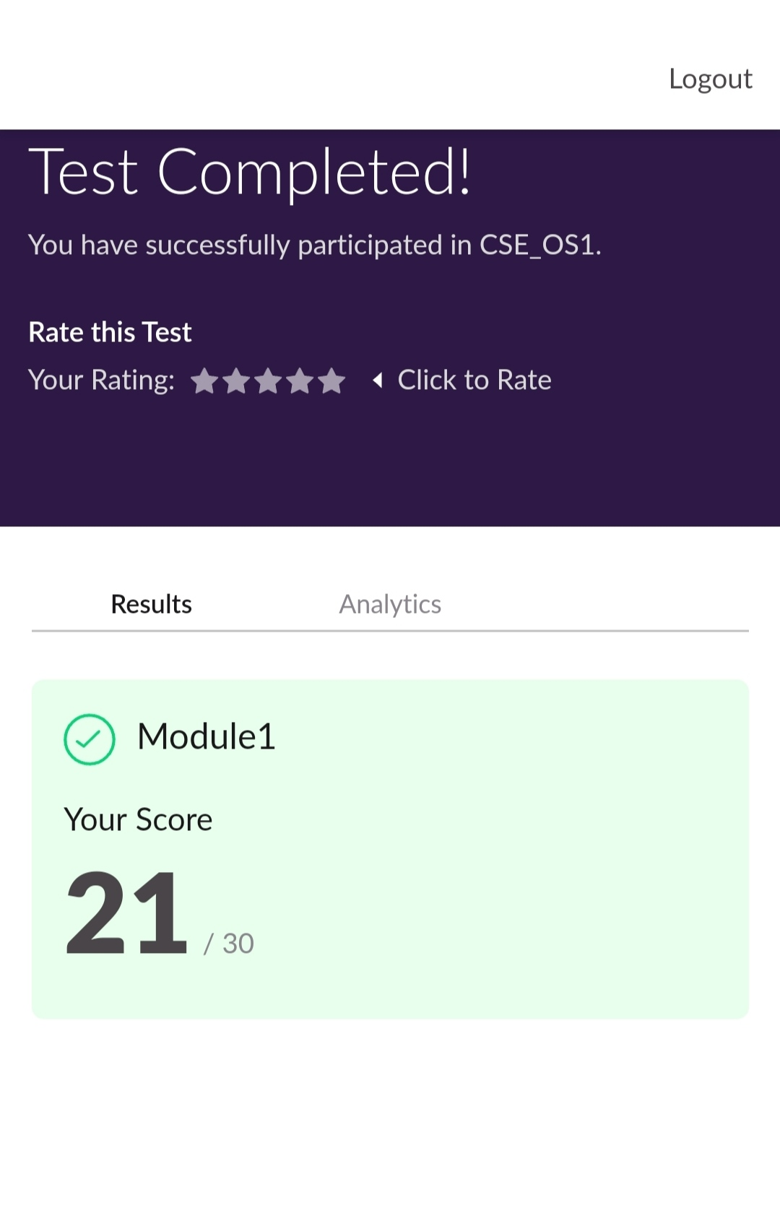

**Certification Course Summary:**

I continued with DIGITAL SECURITY AWARENESS, I completed module 3,4,5 and after ecah module I had to answer assessment and the criteria for qualification was above 80%.The module covers :

* Social engineering defense, manipulation of data and precautions to protect your data.
* What criminals do with you're identity,how you can tell if you're a victim,and action to be taken if you're a victim.
* Data classification,how to classify data, type of classification etc.

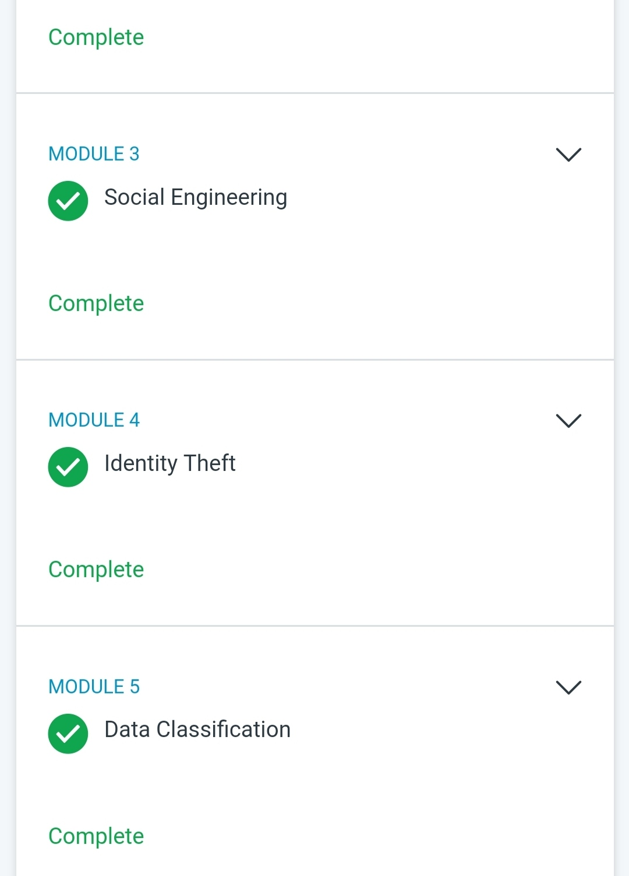

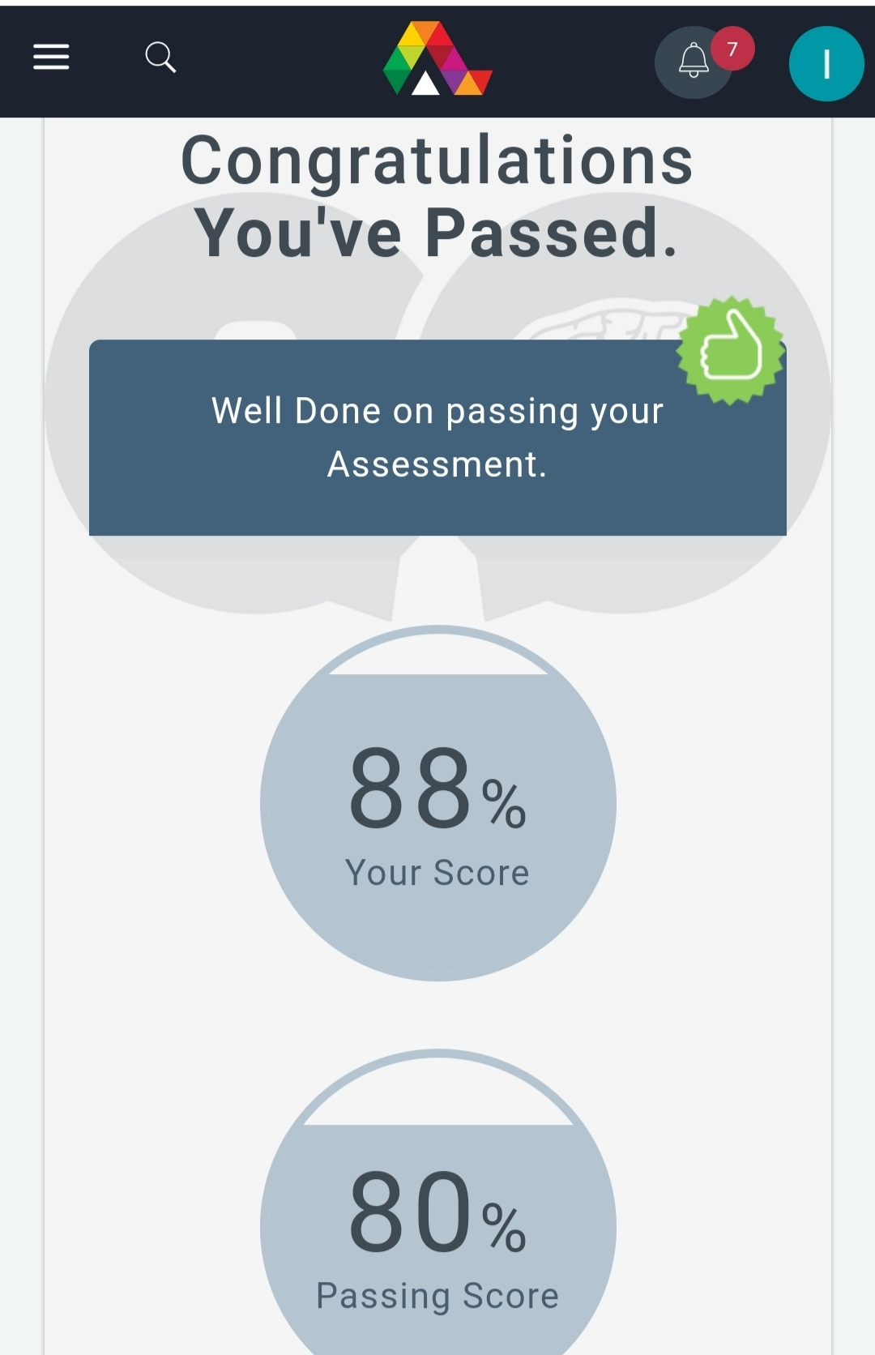

**Coding Challenges:**

Today I solved 2 coding challenge,

**1. First Create a Singly Linked List Stack with the node corresponding to First Element is the base of the stack; and its link field must be always Null.  
When you push First Element, it is the First and it is Base of the stack. Its Link must be Null. top pointer pointing to First. (top = First)  
When you push any element, (No need of checking Stack full case because SLL is dynamic) Create a new node called temp using malloc function and insert a number into Data field, and Link field must be pointing to top; and move the pointer top to point to temp.  
When you pop, First check for stack Empty. if First == NULL, then Stack Empty. If it is not empty, the pointer temp must be pointing to top. Move the pointer top to top->link. delete temp.  
When you display the stack element, First Check for Stack Empty as in pop operation. If it is not empty, display all the elements of current stack starting from top to First.**

**2.Write a C or Java program to implement round robin type of process scheduling.  
Input: Process with burst time, arrival time and specify the time quantum  
Output: Processes scheduled based on the round robin type of scheduling, with its average waiting time.**

